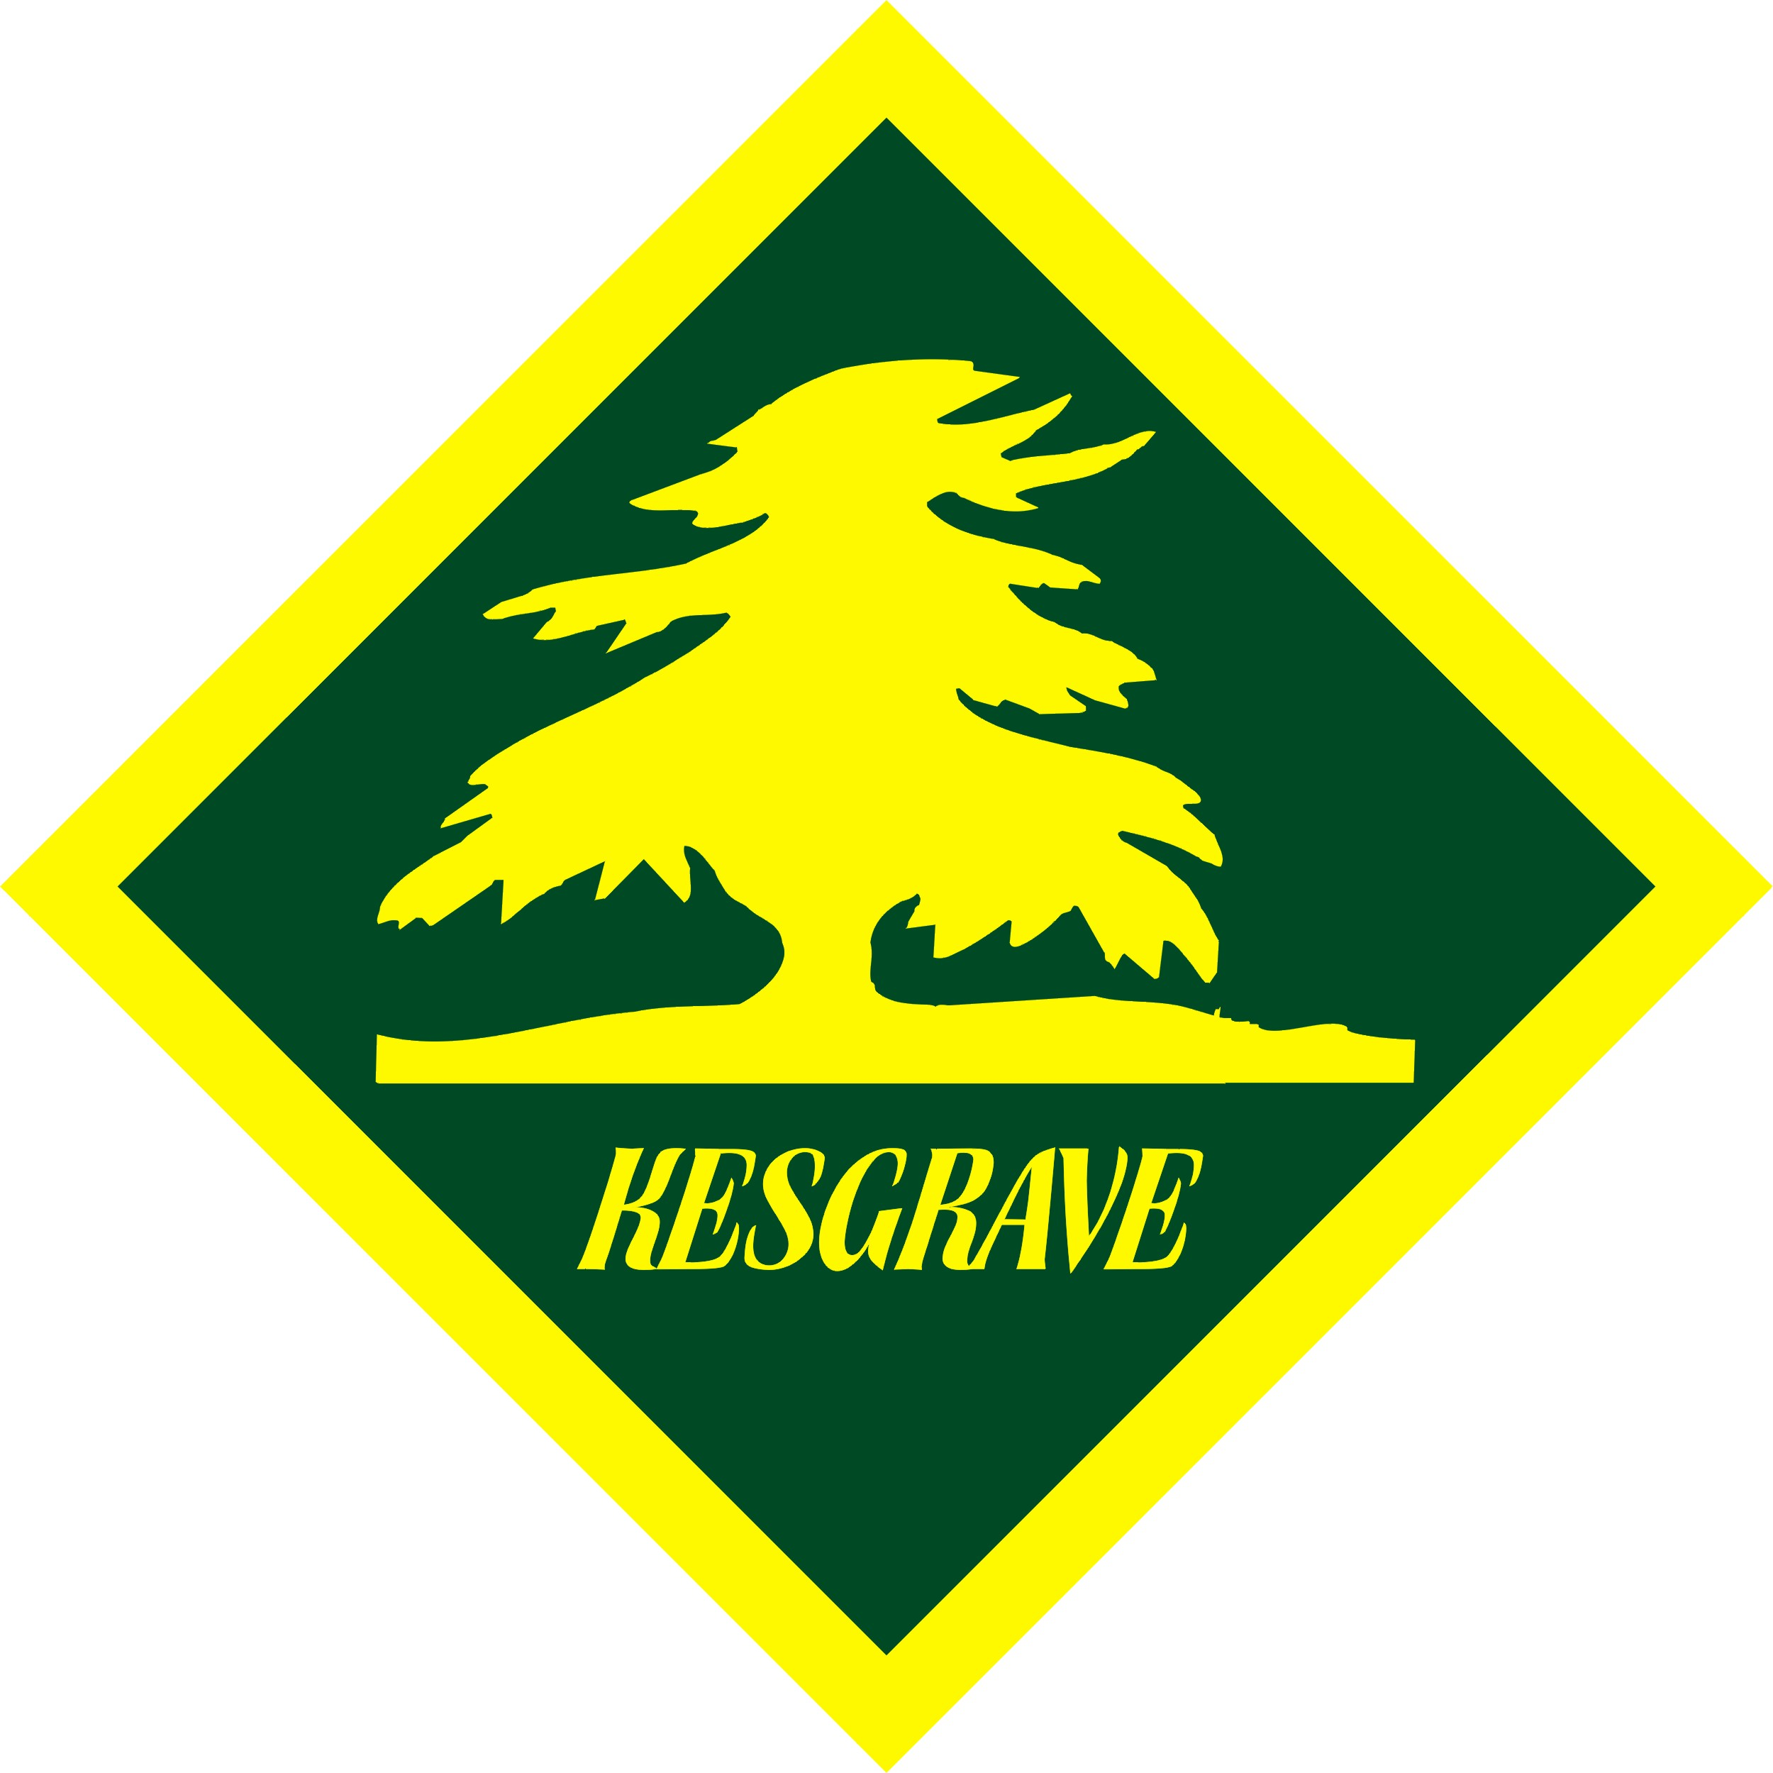 | 1st Kesgrave Scout Group  Twelve Acre Approach, Kesgrave, Suffolk IP5 1JF

External Activities Check List
Event: ________________________________________________________________________

Location: Anywhere.
Activity covered by this assessment:
This covers everything that should be in place before an External Activity along with monitoring for the duration of its use.
Item | Checked/Action
Traffic / dropping off / picking up measures
- dropping off and picking up area suitable and safe for participants.
- are numbers high enough to consider the use of minibuses, coaches etc in order to reduce potential issues.
- should participants be encouraged to share transport.
Venue
- does the venue need visiting / physically checking before the event.
- can the activity be catered for safely at the venue taking account of numbers taking part, space required, free movement of people etc
- is the area at risk from mosquitos, ticks, snakes, animal faeces etc and appropriate measures taken.
- can the area be accessed by any vehicles that need to safely – cars, trailers, mini-busses, coaches, lorries etc
Facilities
- does the venue have all the necessary facilities eg fresh drinking water, toilets, changing areas, showers, lockers etc.
- are additional facilities required and need taking along eg gazebos, etc.
Protrusions, slips, trips, falls, collisions
- is the venue area suitable for the activity being undertaken eg no unnecessary holes, bumps, drops, trip hazards etc; free from clutter, spills and protrusions etc.
- are lighting levels commensurate with the activity(s) being undertaken
Kit / Equipment
- does any kit need to be taken by the leaders/organisers eg pens, paper, first aid kits etc and is in good working order and fit for purpose ie no faults, damage, sharp edges, etc. and if not fit for purpose or unsafe to use, taken out of service and repaired/replaced as appropriate.
Materials / Rubbish
- are arrangements in place to remove rubbish and unused materials at appropriate intervals during the activity.
- at the end of the activity ensure the building/venue/area being used and surroundings are clean and tidy, fit to be used by the next user and personal items, debris and litter are disposed of or taken away.
Clothing / Personal kit
- has everyone been provided with a kit list that covers footwear, headwear, clothing, and kit required that is commensurate for the venue, terrain, activity and forecast weather and time of year, along with any spares that should be brought.
- have additional requirements been identified and specified eg mobile phones, snacks, drinks, torches, spare clothing, first aid kits, emergency provisions etc.
- are there any additional safety requirements required and specified including any specific safety requirements / rules specified in POR - hi-viz, no jewellery, hairbands, gloves, balaclavas, glasses straps, wearing helmets, eye protection, buoyancy aids, footwear etc.
- does centrally provided spare clothing or kit need to be taken by the leaders/organisers eg towels, clothing etc
Putting Out / Erecting Equipment
- is all erectable kit eg tables, gazebos, etc being transported, carried and erected safely – adults have suitable experience / training. Young people supervised as required.
Food
- has food been specified / need providing for the event that takes account of the facilities and cooking options available, and the activities undertaken, that is nutritionally healthy and provides sufficient calories to cover the expected energy levels required and takes account of dietary and allergy requirements of the participants.
- are food storage arrangements available to meet food safety guidelines ie keeping food fresh, etc and provide adequate protection eg sandwich box etc.
- are appropriate food and waste material arrangements available to store correctly and dispose of at the end.
Kitchen, Drinks, Tuck, Refreshments
- are any catering/eating area(s) organised/laid out to minimise risks eg making drinks in a different area to cooking food and preparing food.
- are good food hygiene practices in place / available eg hand washing facilities, washing up facilities.
- has any brough food, tuck etc been checked for being in date
- are suitable cleaning products and equipment available.
- is access to and transporting of hot water being managed safely.
Preparation
- have parents been informed of the outline details of the activity – where, duration, likely weather conditions, clothing and kit required to ensure those taking part know what they are taking on and all parties are happy the participants are qualified / capable enough to undertake the activity safely. Suggest training beforehand etc.
- ask to see the activity providers risk assessment / Licence (AALA etc) / Insurance Cover if appropriate.
- ask to see the activity providers activity qualifications (BCU etc) if appropriate and that someone has a suitable first aid qualification.
- Check for any special forms/requirements that need completing / meeting.
- Check for any special clothing/kit required and let participants know what they need to bring.
- Confirm/check that parents have provided consent to undertake the activity
- Check whether the service provider needs to be aware of any health issues (behavioural or disabilities) so they can take account of them wrt the number and suitability of the instructors they provide and also to make reasonable adjustments to accommodate them. If they do then ask when they need to know before the day or on the day and check health forms or obtain the information and supply.
- agree what the scout leaders/helpers level of participation/role is and plan accordingly.
- does any kit (gazebo etc), equipment, food, emergency ration packs, snacks hot/cold drinks need to be taken by the leaders/organisers.
- have you checked if the activity has any specific safety requirements / rules including any specified in POR eg wearing helmets, eye protection, footwear etc and act accordingly.
Activity Area
- is the area and set up/layout, appropriate for the event / activity(s) eg surfaces, spacing, kit used etc.
- do any areas need cordoning off and inaccessible to others and the public.
Activity
- have participants turned up:
- wearing the appropriate footwear, headwear and clothing for the event, terrain, weather conditions and time of year,
- with any jewellery, hair etc appropriately worn for the event.
- carrying any necessary kit, spare clothing, food, water and any other additional requirements specified.
- and being worn/carried appropriately ie no loose clothing, shoelaces tied, pockets emptied of inappropriate items etc.
If not act accordingly.
- is any clothing, equipment or kit brought by participants not fit for purpose ie damaged, unsafe or not suitable, if so act accordingly.
- is personal PPE such as eye protection, helmets, buoyancy aids, footwear, hair covers, catering gloves and aprons required, available and being worn.
- is PPE, kit and tools required to handle hot items eg pots, pans, lids etc, safely available and being used eg oven gloves, hot cloths, tea towels, tongs, or appropriate lifting devices etc.
- are hi-viz vests, day/ruck sack covers available and being used.
- do participants need sorting into smaller groups Do groups need to be matched in terms of ability, temperament, working together, etc.
- is a participant’s briefing required covering issues such as:
- rules / instructions / guidelines for the activity(s).
- do leaders need to consider carrying spare kit, clothes, food, drinks etc.
- monitor activity including:
- Suitability of clothing, kit etc. Is any clothing, kit and equipment provided in good working order, fit for purpose ie no faults, damage, sharp, parts aligned etc and suitable for the age of the people involved ie is it safe to use.
- Are the personnel delivering the activity competently.
- Following all safety supervision / health instructions by the operator or instructors.
- Monitor the usage of any kit, clothing and equipment being used stop activity if it feels unsafe.
- Monitor participants and flag up any issues with the instructors / supervisors.
Manual Handling
- has the venue been laid out to minimise the need to carry kit and equipment any further than is necessary and/or allow vehicles as close as possible to where it needs to be delivered (commensurate with minimising any traffic issues).
- are protective gloves, safety footwear, googles etc needed and available.
- if appropriate are mechanical aids available to lift heavy kit and equipment during the event.
- is any lifting training/reminders required.
- is any personal equipment or kit packed so that it is light enough to be carried on/off site and during the activity ie not overweight.
- is any equipment and kit required for the activity(s) within the capability of the individuals carrying it and safe.
- is any kit being carried by participants ie on their backs or in their hands, within the capability of the individuals carrying it and safe. If not act accordingly.
Personal Hygiene and Well Being
- do participants have sufficient/adequate personal care products for the activity taking in to account the venue, time of day and the time of year eg sun cream, lip balm, glasses, torch, hats etc.
- are separate arrangements required to deal with feminine hygiene issues.
- have issues such as ticks, mosquitos, snakes etc been taken account of eg wearing long trousers/shirts, insect repellent etc.
- are checks in place to ensure that everyone is eating / drinking / washing adequately, have any injuries dealt with quickly and in a good temperament.
- If any participant is taking regular medicines, they have them with them or with a designated person and take at the prescribed time.
- If someone has a serious medical condition, they are carrying appropriate medicines eg inhalers, EpiPens etc. with them or given to an adult to carry. Ensure it is in a suitable container and location known and someone can administer it in an emergency.
- has the event been assessed for needing measures to be put in place to identify health issues in emergency situations eg arm/wrist bands, id cards, stickers etc marked with the issue – EpiPen, serious allergy, gluten free etc.
- for water based activities are participants able to swim 50 metres in clothing and equipment appropriate to the activity (where a buoyancy aid or life jacket is worn for the activity this may be used for the demonstration) and keep afloat for five minutes. If not, at the discretion of the person in charge, ensure appropriate precautions are taken. See POR 9.13.1.3.
- if required for an activity, specify any criteria required ie can swim 50m, parent permission (air rifles say) etc
General Behaviour
- are any participants likely to be unsafe due to their behaviour and appropriate measures taken.
- have participants been briefed on behaviour.
- is a plan in place for any free time.
- are there separate quiet/safe areas available for young people and adults.
Leadership
- have leaders been briefed on their role.
- are there sufficient leaders / helpers available to manage the number of participants.
- Check if the activity is permitted by the Scout Association / covered by Scout Insurance.
Public and other users
- have all participants been briefed on required behaviour and code of conduct.
Accessibility / Inclusiveness / Health Issues
- have accessibility, ability, disability, age, gender, dexterity, behavioural issues etc been taken account of in the planned activity and any activity groups set up.
- has dietary, allergy or other health issues (asthma, weak bones, claustrophobia, vertigo, can’t swim etc) been taken account of for the activity. Also have health forms be checked for people with allergies etc and minimise the potential contact/use of possible allergens or use alternatives. Examples issues: nuts in food etc
- has the planned activity taken account of additional environmental hazards such as heatstroke, sunburn, ticks and other insects and animals.
Fire Alarm / Equipment / Emergencies / Incidents
- is appropriate fire equipment eg fire blankets/extinguishers available or locations known.
- is an emergency evacuation process in place and participants informed of the signal and what they need to do if they hear the signal.
- is a mobile phone or alternative arrangements available and easily accessible for emergencies.
- are there sufficient mobile phones / alternative arrangements to deal with an emergency.
- are mobile phone signals adequately guaranteed throughout the site. If not consider whether radios would be an appropriate alternative at times or ensure people know where to go to obtain a signal.
- is a robust InTouch process in place.
- are group details, Intouch and health information readily available in case of an incident or emergency either in paper format or electronic eg OSM.
- If groups are split into smaller groups for activities consider whether the group leader needs to maintain a list of who is in each group and have their contact details and any details of any medical or other issues readily available.
- have arrangements been put in place for personal/confidential/Intouch information being secured and only accessible to people that need to access it.
- has a first aid, emergency, sending someone home or cancellation procedure been put in place and do leaders participants know what it is.
- can you accurately define the location in the event of an emergency ie contacting the emergency services, parents etc.
- do participants need to be told a location where a leader will be at all times.
Emergency Exit Points / Access Routes
- is the location accessible to emergency vehicles and in particular ambulances.
- are emergency exit points known and not locked or blocked.
First Aid / Injuries that need treatment
- as a minimum has someone attending have a valid basic first aid certificate and first aid kit.
- are there sufficient qualified first aiders present to deal with the numbers taking part and the types of injuries for the activity being undertaken. Is a dedicated first aider required.
- are sufficient basic first aid kits available plus any additions to take account of the activities being delivered, terrain and weather conditions.
- have first aid kits been inspected for out-of-date items and put aside/ replace.
- check that no pills or medication is stored in general first aid kits and if any pills/medication is required it is stored separately.
- are the details of the local A&E department, local doctors, pharmacies etc known.
- are facilities available to securely store, and if necessary keep cool, any personal medication requirements for young people and someone to supervise the schedule of taking/administering medications.
- if appropriate have instructions been provided for certain diseases – weils, ticks etc.
- if required has an accident form / HQ process been completed.
Security / Theft
- is a secure facility for valuable items required and available eg a locker.
- have all participants been briefed on their responsibility for any valuable items.
- have measures been put in place to minimise theft.
Safeguarding / Lost
- are adequate supervision ratios in place.
- has the venue been assessed for being an area where stranger / public access is likely and appropriate measures considered eg wearing of scarves, arm/wrist bands, group branded t-shirts etc.
- is a clear procedure for handing over eg dropping off and collecting, young people, that is appropriate for the age ranges taking part, in place and parents informed of the details.
- have all participants been briefed on how they should deal with strangers, the site layout / boundaries to stay within, the location of facilities, what to do if lost / separated, keeping in groups/accompanied by someone else, not wandering off, etc
- have arrangements been put in place to keep a register of people taking part, what groups they are in and changes throughout the event, along with head counts.
- has a lost/separated person procedure been put in place.
- is a ‘In case of Emergency’ (ICE) form required and provided to participants.
- consider the need for young people to use their own mobile phone.
DBS / Scouting
- are all adults (leaders and any helpers) and young leaders aware of current scouting guidelines eg yellow card etc or recent rule changes.
Other Control Measures
- do any adventurous activities, leaders or third-party organisations, have the necessary insurance and activity permits, and if necessary, Scout Insurance (Unity) aware / confirmed activity covered.
- have any injuries, near misses, loss or damage of property, faulty/unsafe equipment, out of date or missing first aid items, etc been reported to the Trustees for discussion at their regular meetings.
Weather
- has the weather forecast been monitored leading up to the event and appropriate adjustments made and bad weather activities ready if required. Are plans in place to monitor the weather during the event and adjust activities as required.
- are torches required.
Notes:
Signed:  Position: | Date:  Review date:

