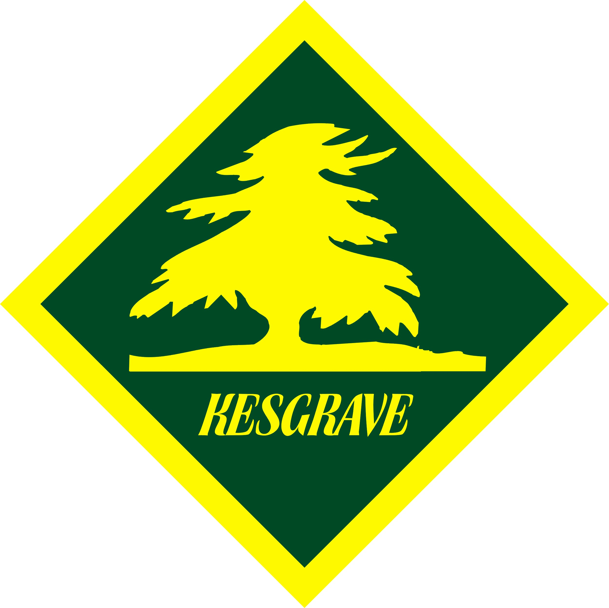 | 1st Kesgrave Scout Group  Twelve Acre Approach, Kesgrave, Suffolk IP5 1JF

Games Check List
In addition to the Section Meeting and Event Check List
Event: ________________________________________________________________________

Location: Any Location - Scout Hall, surrounding area, Kesgrave and generally for any building, location, activity, event, or meeting.
Operation covered by this assessment:
This covers everything that should be in place for games.
Item |  | Checked/Action
Lone working
- lone working measures in place.

Venue
- does the venue / location need visiting / physically checking before the game(s) take place.
- is the area suitable eg level enough, no drops, not too near water etc.
- is the area at risk from mosquitos, ticks, snakes, animal faeces etc and appropriate measures taken.
- can the game(s) be catered for safely taking account of numbers taking part, space required for the game etc.

Facilities
- are additional facilities required eg gazebos, etc.

Protrusions, slips, trips, falls, collisions
- is the playing surface suitable and safe eg no holes, bumps, loose carpet edges, electrical cables, water pipes, ropes, icy, wet, tree roots etc.
- is the area free from sharp, damaged, or protruding permanent and movable fixtures eg cupboards, shelving, play equipment etc.
- do any permanent or moveable objects eg cupboards, trees, poles etc) need roping off or protecting with a soft material to minimise collision issues.
- is the area free from clutter, rubbish, spills, shards etc.
- are lighting levels commensurate with the game being undertaken.
- Is the playing surface soft enough for the game to minimise contact injuries or are crash mats or other suitable solutions required and in place.
- are doors and gates appropriately open or closed/locked.
- are appropriate barriers / bollards / cordoned off areas required and in place.
- is the area laid out safely ie structures in straight lines, tied down adequately, hazard tape used where appropriate, gaps between items suitable, etc.
- are all walkways, public areas etc clear and free from trip hazards, protrusions etc
Storage Area
- are designated areas set aside for the storage of the games kit and potentially dangerous items eg fuels, knives, etc and appropriately protected and for dangerous items ideally locked away.

Kit / Equipment
- is any provided games equipment and kit being used:
- in good working order and fit for purpose ie inspected for obvious damage, faults, sharp edges etc, and if not fit for purpose or unsafe to use and taken out of service and repaired/replaced as appropriate.
- suitable for the environment being used (indoors / outdoors), and appropriate for the age of the people involved ie can they use it safely etc. and as safe as practical ie soft, lightweight etc
- are appropriate transportation mechanisms (trolleys etc) required and in place to move kit and equipment to and from the location of the game and fit for purpose, not overloaded etc.
- consider counting in and out potentially harmful and attractive kit and equipment etc
- is all the games equipment and kit, being used, stored, locked and stacked safely when used and not being used.
- is the games equipment, kit etc being removed and placed in a safe area or designated storage area when no longer required and being put away clean and dry at the end of the meeting or event, appropriately stacked/stored and in the correct locations.
Electrical Considerations (if applicable)
- is any electrical equipment being used appropriate, PAT tested, inspected and safety trips in place, especially if used outside or likely to suffer from condensation or water ingress.
- are any electrical installations (lighting, audio system etc) set up, connected and working correctly with sockets not overloaded, no multiple way adaptors cascaded, protected by trips etc.
- has any electrical equipment and kit been put away clean and dry at the end of the meeting or event, appropriately stacked/stored and in the correct locations.
Gas Considerations (if applicable)
- is any gas equipment being used appropriate, tested and inspected for damage.
- are any gas appliances set up correctly ie tested for leaks, bottles upright and positioned correctly, stored correctly etc)
- is a gas management strategy in place.
- are carbon dioxide detectors in place.
- has any gas equipment and kit been put away clean and dry at the end of the game, appropriately stacked/stored and in the correct locations.
Fire / Hot Surface Considerations (if applicable)
- is any equipment being used appropriate, tested and inspected for damage.
- if appropriate, are measures (storage, handling, PPE, use, fire precautions, emergency procedures, first aid /burns kits etc) in place for the use of any fires, hot surfaces etc.
- are naked flames (burners, fires etc) or hot surfaces located away from flammable substances or materials and not being used directly on inappropriate surfaces such as tables, tarmac surfaces, grass etc to minimise burn risks, damage and fires getting out of hand.
- has any fire / hot surface equipment and kit been extinguished, left to cool and if appropriate put away clean and dry at the end of the meeting or event, appropriately stacked/stored and in the correct locations.
(use additional check lists for cooking and open fires)
Fuels , Chemicals, Solvents, Adhesives Considerations (if applicable)
- are any fuels, chemicals etc being used, stored in appropriate safe containers/packaging and stored safely.
- if appropriate, are measures (storage, handling, PPE, use, training, emergency procedures/equipment, first aid/burns kits etc) in place for the use of any chemicals, solvents, glues, fuels etc
- is the area well ventilated.
- are any fuels, chemicals, solvents, adhesives etc been put away clean and dry at the end of the meeting or event, stored in a safe container /packaging, and appropriately stacked/stored and in the correct locations.

Materials / Rubbish
- are arrangements in place to remove rubbish and unused materials at appropriate intervals during the activity.
- at the end of the game ensure the building/venue/area being used and surroundings are clean and tidy, fit to be used by the next user and personal items, debris and litter are disposed of or taken away.
Clothing / Personal kit
- has everyone been provided with a kit list that covers footwear, headwear, clothing, and kit required that is commensurate for the venue, type of game, terrain, forecast weather and time of year, along with any spares that should be brought.
- have additional requirements been identified and specified eg mobile phones, snacks, drinks, torches, eye protection, retainers for glasses, spare clothing, first aid kits, emergency provisions etc.
- are there any additional safety requirements required and specified including any specific safety requirements / rules specified in POR - hi-viz, no jewellery, hairbands, gloves, glasses straps, eye protection, footwear, whistle etc.
- is centrally provided spare clothing or kit need to be taken by the leaders/organisers eg towels, clothing etc
Putting Out / Erecting Equipment
- is all erectable kit eg flags, goals etc erected safely – adults have suitable experience / training. Young people supervised as required.
Preparation
- Do parents need informing of the outline details of the event/activity especially if away from the hall – where, duration, activities undertaken, clothing and kit required etc.
Game Area
- is the area and set up/layout, appropriate for the game(s) eg surfaces, spacing, kit used, storage area etc.
- does the play area need cordoning off and inaccessible to others and the public, so no one can get between the player and targets etc.
Game Play
- is the game intrinsically safe and contact avoided as much as possible ie the game is unlikely to cause physical harm. Tagging not take down, no holds around the neck, twisting limbs etc.
- have participants turned up:
- wearing the appropriate footwear, headwear and clothing for the venue, game(s), terrain, weather conditions and time of year,
- with any jewellery, hair etc appropriately worn for the activity.
- bringing any necessary kit, spare clothing, food, water and any other additional requirements specified.
- and being worn/carried appropriately ie no loose clothing, shoelaces tied, pockets emptied of inappropriate items etc.
If not act accordingly.
- is any clothing, equipment or kit brough by participants not fit for purpose ie damaged, unsafe or not suitable and if so, act accordingly.
- is personal PPE such as eye protection, helmets, footwear, gloves, shin guards, hair covers, required available, and being worn.
- is PPE, kit and tools required to handle hot items eg pots, pans, lids etc, safely available and being used eg oven gloves, hot cloths, tea towels, tongs, or appropriate lifting devices etc.
- are hi-viz vests, day/ruck sack covers available and being used.
- do participants need sorting into smaller groups/teams. Do groups/teams need to be well matched in terms of size, height, weight, age, ability, temperament, working together, etc.
- are any rules, safety rules and guidelines required for the game(s) and available and need explaining clearly and concisely before commencing the game. For example, throwing below head height, sticks to be kept at knee level, area of play defined, clothing etc.
- do players need to be given training / a demonstration of how to use the games equipment correctly before play or activity starts. Ie darts, throwing etc.
- do leaders need to consider carrying spare kit, clothes, food, drinks etc.
Manual Handling
- has the venue been laid out to minimise the need to any kit and equipment any further than is necessary and/or allow vehicles as close as possible to where it needs to be delivered (commensurate with minimising any traffic issues).
- are protective gloves and safety footwear needed and available.
- if appropriate are mechanical aids available to lift heavy kit and equipment during the event.
- is any lifting training/reminders required.
- is any equipment and kit required for the game within the capability of the individuals carrying it and safe.
- is any kit being carried by participants ie on their backs or in their hands, within the capability of the individuals carrying it and safe. If not act accordingly.
- is any equipment and kit required for the game, that is on top of cupboards or above head height, safe and can be lifted down and put back safely.
Personal Hygiene and Well Being
- do participants have sufficient/adequate personal care products for the game(s) taking in to account the venue, time of day and the time of year eg sun cream, paracetamol, lip balm, glasses, hats etc.
- have issues such as ticks, mosquitos etc been taken account of eg wearing long trousers/shirts, insect repellent etc.
- If someone has a serious medical condition, they are carrying appropriate medicines eg inhalers, EpiPens etc. with them or given to an adult to carry. Ensure it is in a suitable container and location known and someone can administer it in an emergency.
- has the activity been assessed for needing measures to be put in place to identify health issues in emergency situations eg arm/wrist bands, id cards, stickers etc marked with the issue – EpiPen, serious allergy, gluten free etc.
- if required for an activity, specify any criteria required ie can swim 50m, parent permission (air rifles say) etc
General Behaviour
- are any participants likely to be unsafe due to their behaviour and appropriate measures taken.
- have participants been briefed on behaviour and safety rules for the game(s) and a clear communication method in place to stop the game in an emergency.
- are there separate quiet/safe areas available for people not taking part in games.
Leadership
- have leaders been briefed on their roles eg supervising, watching, instructing, monitoring, time keeping etc.
- are there sufficient leaders / helpers available to run the games(s) safely.
- do the leaders and helpers running the game(s) have the necessary experience to run them safely.
- is using radios appropriate to manage the game(s) if mobile signals are poor.
Per Led Activities
- are the young people adequately trained and capable of running the game(s).
- is a supervision plan required and in place.
Public and Other site Users
- have all participants been briefed on required behaviour and code of conduct.
Accessibility / Inclusiveness / Health Issues
- have accessibility, ability, disability, age, gender, dexterity, behavioural issues etc been taken account of in the planned game(s) and any teams set up.
- has dietary, allergy or other health issues (asthma, weak bones, claustrophobia, vertigo , can’t swim etc) been taken account of for the game(s). Also have health forms be checked for people with allergies etc and minimise the potential contact/use of possible allergens or use alternatives. Examples issues: nuts in food etc
- has the planned game(s) taken account of additional environmental hazards such as heatstroke, sunburn, ticks and other insects and animals.

Fire Alarm / Equipment / Emergencies / Incidents
- is appropriate, is fire equipment eg fire blankets/extinguishers available or locations known.
- is a mobile phone or alternative arrangements (landline) available and easily accessible for emergencies.
- are there sufficient mobile phones / landlines to deal with an emergency.
- are mobile phone signals adequately guaranteed throughout the site. If not consider whether radios would be an appropriate alternative at times or ensure people know where to go to obtain a signal.
- is a robust InTouch process in place.
- are group details, Intouch and health information readily available in case of an incident or emergency either in paper format or electronic eg OSM.
- is a first aid or emergency procedure required and in place and do leaders and participants know what it is.
- is an emergency evacuation process in place and participants informed of the signal and what they need to do if they hear the signal.
- can you accurately define the location in the event of an emergency ie contacting the emergency services, parents etc.
- do participants need to be told a location where a leader will be at all times.
Emergency Exit Points / Access Routes
- is the location accessible to emergency vehicles and in particular ambulances.
- are emergency exit points known and not locked or blocked.
First Aid / Injuries that need treatment
- as a minimum does someone attending have a valid basic first aid certificate and first aid kit.
- are there sufficient qualified first aiders available locally to deal with the numbers taking part and the types of injuries that might occur. Is a dedicated first aider required.
- are sufficient basic first aid kits available plus any additions to take account of the game(s) being delivered, terrain wildlife present (ticks, mosquitoes etc) and weather conditions.
- have first aid kits been inspected for out-of-date items and put aside/ replace.
- check that no pills or medication is stored in general first aid kits and if any pills/medication is required it is stored separately.
- if appropriate is a bucket of cold water or a running tap required for the immersion of burn etc.
- if required has an accident form / HQ process been completed.
Security / Theft
- have all participants been briefed on their responsibility for any valuable items.
- have measures been put in place to minimise theft.
Safeguarding / Lost
- are adequate supervision ratios in place.
- has the venue been assessed for being an area where stranger / public access is likely and appropriate measures considered eg wearing of scarves, arm/wrist bands, group branded t-shirts etc.
- have all participants been briefed on how they should deal with strangers, the site layout / boundaries to stay within, the location of facilities, what to do if lost / separated, keeping in groups/accompanied by someone else, not wandering off, etc.
- have arrangements been put in place to keep a register of people taking part, what groups they are in and changes throughout the game, along with head counts especially if individuals can be on their own during the game.
- has a lost/separated person procedure been put in place.
- is a ‘In case of Emergency’ (ICE) form required and provided to participants.
- consider the need for young people to use their own mobile phone.
DBS / Scouting
- are all adults (leaders and any helpers) and young leaders aware of current scouting guidelines eg yellow card etc or recent rule changes.

Other Control Measures
- have any injuries, near misses, loss or damage of property, faulty/unsafe equipment, out of date or missing first aid items, etc been reported to the Trustees for discussion at their regular meetings.
Weather
- has the weather forecast been monitored leading up to the event and appropriate adjustments made and bad weather activities ready if required. Are plans in place to monitor the weather during the event and adjust activities as required.
- are torches required
Notes:
Signed:  Position: | Date(s):  Review date:

